1. **Write a Python program to Get Only unique items from two sets. Input: set1 = {10, 20, 30, 40, 50} set2 = {30, 40, 50, 60, 70}**

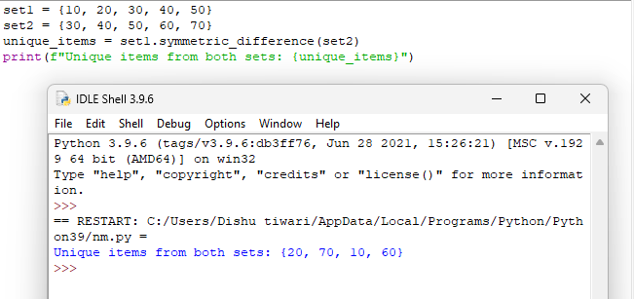

1. **Write a Python program to Return a set of elements present in Set A or B, but not both. Input: set1 = {10, 20, 30, 40, 50} set2 = {30, 40, 50, 60, 70}**

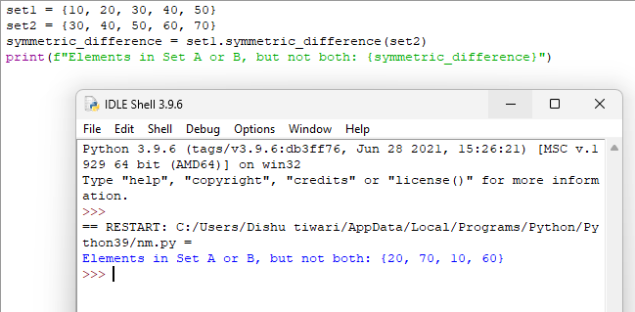

1. **Write a Python program to Check if two sets have any elements in common. If yes, display the common elements. Input: set1 = {10, 20, 30, 40, 50} set2 = {60, 70, 80, 90, 10}**

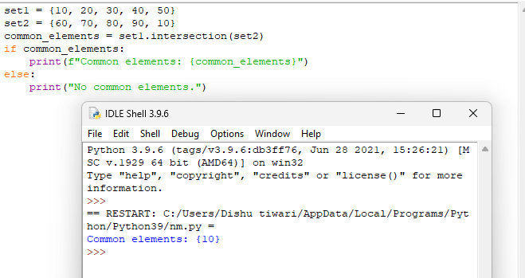

1. **Write a Python program to Remove items from set1 that are not common to both set1 and set2. Input: set1 = {10, 20, 30, 40, 50} set2 = {30, 40, 50, 60, 70}**

